# *Table of Contents*

Introduction……………………………………………………………………………..………………………………..2

Installing the Software.……. …………………………………………………………...………………….………..2

Major Use Cases**..**……………………………………………………….……………………………………………….3

Keyboard Shortcuts……………..……………………………………………………………………………………..4

Troubleshooting……………………..………………………………………………………………………….………6

Contact Us.……………………………………………………………………………………………………………………………7

# Introduction:

To demonstrate to you the user precisely how the application is to be installed, and typically used, below we have included this manual highlighting the installation process, as well as the major use cases alongside the intended purpose of this program, as well as screenshots and step by step instructions demonstrating how the application should behave and operate.

Rationalizing the installation, the installation is highlighted to simply show you the how’s, where’s, and what to do when encountering the application icon either from accessing the program from github, or directly accessing the program via computer.

The major use case simply outlines the can’s, to determine if this program is right for you. Finally, the screenshots are shown to have a clear idea of what should happen, and how each interface connects to one another in the event of any confusion.

# Installation:

Accessing Via Github:

1. Click on or enter in the following link: [https://github.com/DSantaguida/EECS2311- Group17/releases](https://github.com/DSantaguida/EECS2311-%20%20%20%20%20Group17/releases)
2. The application found as a test.jar file, double-click on the application icon, prompting you to choose a storage space for the application itself.
3. Upon storing the application’s destination for storage, the application will run with the designated application prompts. Note that as of now you may run the application locally.

Accessing Files Via Desktop:

1. Open the folder **EECS_2311_Enamel**
   1. Ensure that the file folder is completely extracted
2. Documentation is included detailing the systems requirements, design documents, user manual, and further testing documents for a better understanding.

* Enamel contains all the source code, libraries, and example files to run Authoring App

1. Open Eclipse
   1. Click **Import** > General > **Existing Projects into Workspace** > Browse to the directory containing **EECS_2311_Enamel** > **Finish**
2. Having done all the above steps, you should have full access to The Braille Box (TBB) program.
3. To run the program please press the green play button located in your taskbar to commence the program.

# Major Use Cases:

* Application is used to fulfill the task of reading documents, books and other textual representations using pins.
* Application to aid user in creating documents and other textual artifacts from scratch.
* Application is used to capture the user’s voice and transmit that to a textual representation.
* Application is used to allow users to freely choose between creating, editing, and recording files.
* Application is used to allow user to preview they’re text before creating a file or editing one.

# 

# Screenshots + Guide:

* 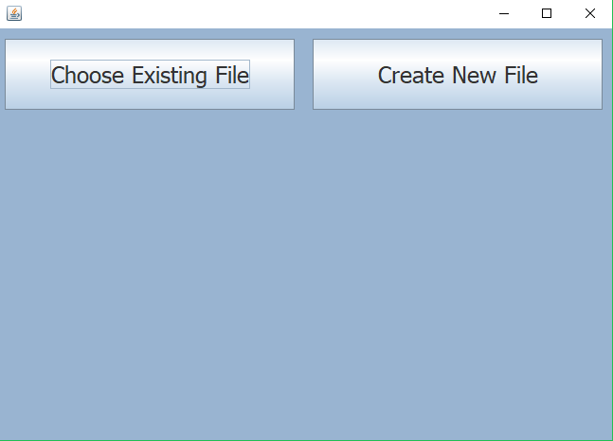Shown to the right is the Start Screen of the program.
* Note that it has two options upon start-up, Create and Choose.
* As the user, you may use existing files, or create your own!
* 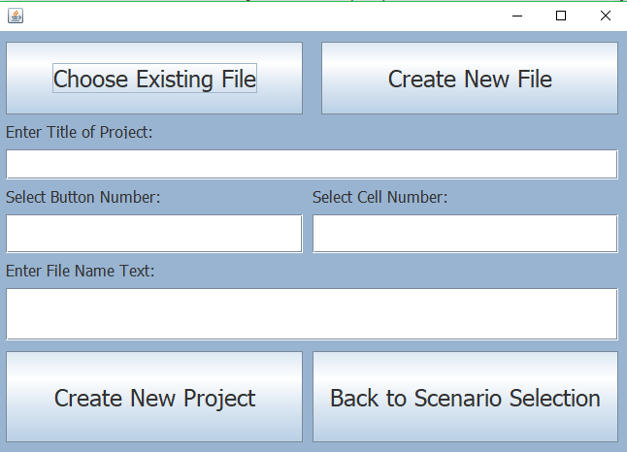Should you choose “Create New File” you will be prompted with a title, number of cells and buttons, and filename.
* These components are crucial as comprise all elements for a better experience!
* When finished hit “Create New Project” to move onto editing, or if you want, “Back to Scenario Selection” takes you back to the first screen shown above.

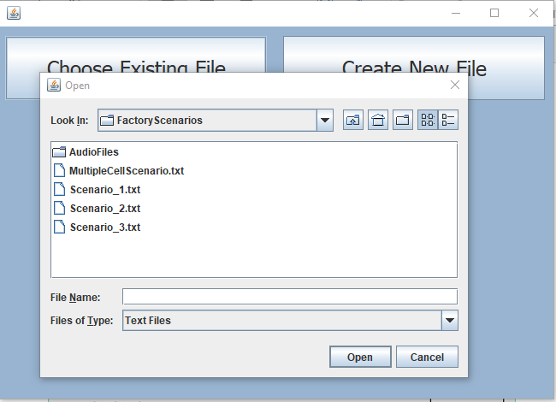

* Should you press “Choose Existing File”, a window will appear prompting you for the destination of the file you would like to use.
* Once decided, press open to begin editing.
* Otherwise press cancel if you would like to create a new file instead!
* Once created/chosen a file you will be prompted to edit your file (This Screen).
* 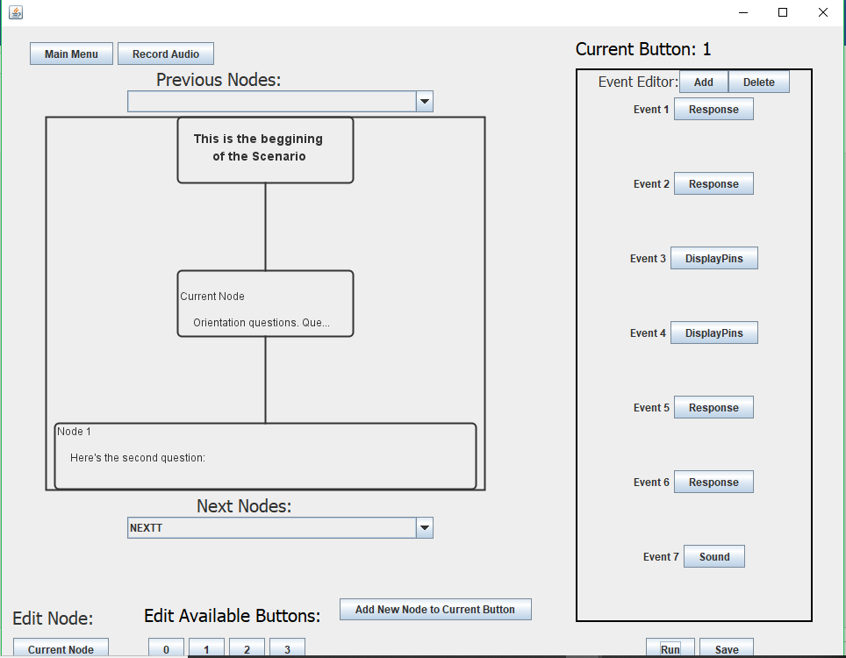To the right is the Event Editor, this is to perform actions when reading your file out later. You may add more layers of actions to your liking!
* At the bottom you will notice that you can choose how many buttons, this is correlated to the pins you see when reading your file later.
* The main menu button will bring you to the first screen shown in this manual.
* 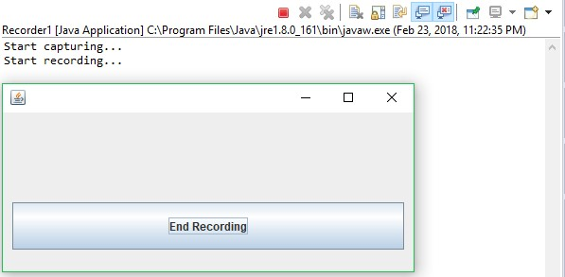The diagram is shown to track your changes and see how they interact, you may switch between nodes if it becomes confusing.
* At the top left is a button to record audio, this brings you to another window starting a recording session, when finished hit “End Recording” to come back to the Editing Screen.
* Upon ending the session, it will prompt you for a filename and destination for the recording.
* The screen shown to the right is the window you will see.

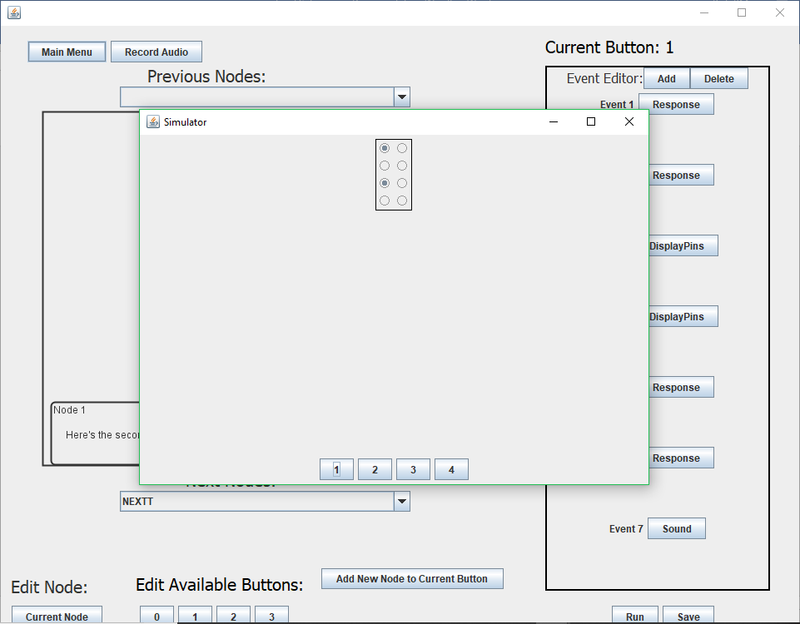

* Once done editing (From 4th Screen), you will see the following screen.
* This is known as the Authoring App which reads out your manipulated file, along with the pins used and the buttons initialized.
* Having done all these parts, you have successfully run a file on this program!

# Keyboard Shortcuts

# The purpose of these keyboard shortcuts (Hotkeys) is designed to benefit yourself instead of navigating the application to find a specific button. These keys in this application are deemed as the most useful and frequent buttons you will use in this program.

A guide is labelled below highlighting each of the hotkeys, and where applicable.

On the Start Screen:

* **Ctrl + S:** Create Scenario
* **Ctrl + T:** Choose Scenario

On the Editing Screen:

* **Ctrl + S:** Save Scenario
* **Ctrl + M:** Main Menu
* **Ctrl + R:** Run Scenario

# Troubleshooting

The Authoring App is an intuitive program capable for anybody’s use, specifically for educators use. Despite this, there are discrepancies that can be fixed easily. For any other questions or concerns, please feel free to reach out for assistance.

Here are some common errors or confusions answered:

|  |  |
| --- | --- |
| **Question** | **Solution** |
| Wy are the Hotkeys are non-responsive? | Please exit out of a text-field if you are not seeing any changes to the program (Inside or outside the application) |
| I am trying to record an audio file, but no sound is being recorded. Why is that? | Ensure the microphone your desktop possesses is connected properly. Close Recording window and Authoring App and try again. |
| I am using a Windows device. Why does NVDA not recognize some text? | NVDA may cause some issues with Authoring App since the user’s environment (32-bit or 64-bit) may vary. Please try the following solution.   1. Control Panel > Ease of Access Center > “Use the computer without a display” > Scroll to the bottom and ensure that **Enable Java Access Bridge** is toggled ON. |

# Contact Us

To contact the individual developers of the program:

**Risheed Malatombee** | rasho95@my.yorku.ca

**Yoni Fihrer** | yoni@my.yorku.ca

**Daniel Santiguida** | dsantaguida@my.yorku.ca

**Steve Sohn** | stevsohn@my.yorku.ca